What is the Value of Controlling a New Invasive Pest?
Regular Crops of High Quality Fruit?
Improved Disease Resistance Management?
Labor Efficient Technologies?

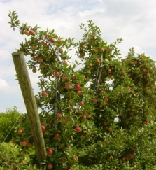
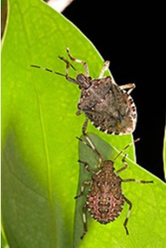
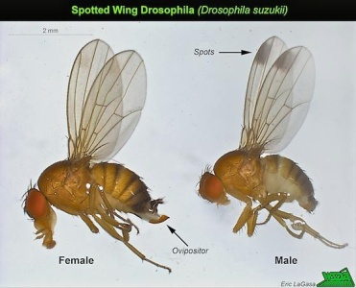
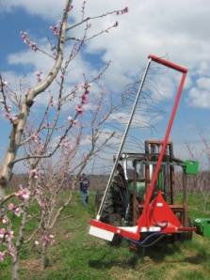
These are questions that we need to consider as we prepare to shape our industry for the next generation!
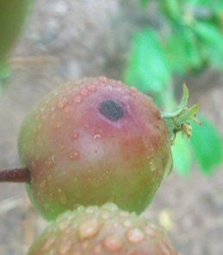
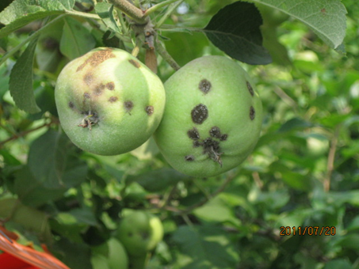
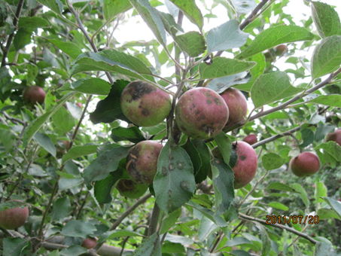
Severe apple scab on Fuji (Left) and Rome (Right) apples at a commercial orchard near Biglerville, Pennsylvania.
Severe apple scab on Fuji (Left) and Rome (Right) apples at a commercial orchard near Biglerville, Pennsylvania.
This is how you can make a difference!
Recognizing the value of specialty crop research and extension work and the contributions to my production and business practices, and also recognizing the need for a sustainable approach to provide industry support to address critical and emerging threats, we/our company makes this commitment to support university research and extension programs through a voluntary annual contribution. We/I also recognize that these funds will be administered by the State Horticultural Association of Pennsylvania, Inc. (SHAP). Estimated annual pledge amount:

__ Platinum level, $2,500+
__ Gold level, $1,000-2,499
__ Silver level, $500-999
__ Bronze level, $250-499
__ Sustaining level, $100
Signature____________________________

Please enclose contribution, made out to SHAP, or check here to receive an invoice in December, 2013.
Name: _______________________________ Company: __________________________________
Address: __________________________________________________State_____ Zip__________
Email: _________________________ Phone: _________________________
Contributors will be acknowledged in PA Fruit News. If you wish to remain anonymous, please check here:
If you currently are not a member of SHAP, please check here for a free trial membership with your contribution of $100 or higher:
Please mail this form to: State Horticultural Association of PA, 480 Mountain Rd, Orrtanna, PA 17353.
The SHAP Board of Directors approved a resolution to increase university research and extension support by $100,000 per year by 2016. We are encouraged by a fresh market industry commitment to double their contribution from $.01 to $.02/packed box but this will not be adequate to attain our goal. Additional sources will be necessary, and if you do not already provide voluntary support, we encourage you to consider making a pledge. Special thanks to all who have responded so far to this campaign! We welcome any suggestions you may have for projects—please contact any member of the SHAP research or extension committee.

